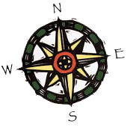 | Career Navigation | Ph: (949) 722-6232
 | Orange County, CA 92663 | Fax: (949) 645-6658
 |  | lynn@career-nav.com

NEW SEARCHES

Location: Greater San Francisco Bay Area

Interested in being a part of a company that focuses on the success of clients through the management and growth of their customer base? This start-up cultured company revamps the obsolete to modern software in the fast growing ticketing service field.

***VP Customer Success or Director Level ***

Critical Areas:
- Successes: Manage technology solution; Hire, Train, Coach, and Mentor customer support staff
- Evaluate and Implement Customer Service Software (Ex: Zen Desk, Fog Bugz, Using Salesforce)
- Continually Create, Manage, and Implement budgets and strategic plans for optimal department performance
- Reports directly to CEO; provides communication between department heads to ensure needs are met

Prefer:
- BA degree
- Years of experience in managing customer support, ticketing industry, CRM and SaaS
- Strong leadership and superior communication skills
- Understanding of technical support issues related to software

Job Code: 20309DCS

Please send your resume to lynn@career-nav.com along with the job code number in the subject line.

